**PATFIN NURSERY AND PRIMARY SCHOOL, AKESAN, LAGOS STATE.**

**THIRD TERM EXAMINATION [ 2017 / 2018 ]**

**CLASS : K . G 1**

**NAME : ______________________________________ SUBJECT: HEALTH – EDUCATION**

**INSTRUCTION : ANSWER CORRECTLY DURATION : 1 HOUR**

1. I must take my bath __________ [ Every week, Everyday ]
2. Our toilet must be ________ . (a) Dirty (b) Clean
3. Mention two things we can use to clean our home .
4. _______________
5. ____________________
6. I must wash my hands before I eat. [ Yes / No ]
7. The chair I sit on must be free from dust [ Yes / No ]

**PATFIN NURSERY AND PRIMARY SCHOOL, AKESAN, LAGOS STATE.**

**THIRD TERM EXAMINATION [ 2017 / 2018 ]**

**CLASS : K . G 1**

**NAME : ______________________________________ SUBJECT: HEALTH – EDUCATION**

**INSTRUCTION : ANSWER CORRECTLY DURATION : 1 HOUR**

1. I must take my bath __________ [ Every week, Everyday ]
2. Our toilet must be ________ . (a) Dirty (b) Clean
3. Mention two things we can use to clean our home .
4. ____________
5. _______________
6. I must wash my hands before I eat. [ Yes / No ]
7. The chair I sit on must be free from dust [ Yes / No ]

**PATFIN NURSERY AND PRIMARY SCHOOL, AKESAN, LAGOS STATE.**

**THIRD TERM EXAMINATION [ 2017 / 2018 ]**

**CLASS : K . G 1**

**NAME : ______________________________________ SUBJECT: SOCIAL – NORMS**

**INSTRUCTION : ANSWER CORRECTLY DURATION : 1 HOUR**

1. Should you rush your food? [ Yes / No ]
2. What is the name of your school?

________________________________________________________________

1. Our dining table must be __________ . (a) Rough (b) Neat (c) Clean
2. Boys prostrate while girls ________________ (a) Cry (b) Stand (c) Kneel
3. I must obey my parents. [ Yes / No ]

**PATFIN NURSERY AND PRIMARY SCHOOL, AKESAN, LAGOS STATE.**

**THIRD TERM EXAMINATION [ 2017 / 2018 ]**

**CLASS : K . G 1**

**NAME : ______________________________________ SUBJECT: SOCIAL – NORMS**

**INSTRUCTION : ANSWER CORRECTLY DURATION : 1 HOUR**

1. Should you rush your food? [ Yes / No ]
2. What is the name of your school?

________________________________________________________________

1. Our dining table must be __________ . (a) Rough (b) Neat (c) Clean
2. Boys prostrate while girls ________________ (a) Cry (b) Stand (c) Kneel
3. I must obey my parents. [ Yes / No ]

**PATFIN NURSERY AND PRIMARY SCHOOL, AKESAN, LAGOS STATE.**

**THIRD TERM EXAMINATION [ 2017 / 2018 ]**

**CLASS : K . G 1**

**NAME : ______________________________________ SUBJECT: BASIC SCIENCE AND TECHNOLOGY**

**INSTRUCTION : ANSWER CORRECTLY DURATION : 1 HOUR**

1. How many Legs do you have? _______ (a) 5 (b) 2
2. A balanced diet is good for the body. [ Yes / No ]
3. I can see with my _________ . (a) Nose (b) Eyes
4. I move with my _______ (a) Hands (b) legs
5. Water on the stove or fire is _______ (a) Cold (b) Hot

**PATFIN NURSERY AND PRIMARY SCHOOL, AKESAN, LAGOS STATE.**

**THIRD TERM EXAMINATION [ 2017 / 2018 ]**

**CLASS : K . G 1**

**NAME : ______________________________________ SUBJECT: BASIC SCIENCE AND TECHNOLOGY**

**INSTRUCTION : ANSWER CORRECTLY DURATION : 1 HOUR**

1. How many Legs do you have? _______ (a) 5 (b) 2
2. A balanced diet is good for the body. [ Yes / No ]
3. I can see with my _________ . (a) Nose (b) Eyes
4. I move with my _______ (a) Hands (b) legs
5. Water on the stove or fire is _______ (a) Cold (b) Hot

**PATFIN NURSERY AND PRIMARY SCHOOL, AKESAN, LAGOS STATE.**

**THIRD TERM EXAMINATION [ 2017 / 2018 ]**

**CLASS : K . G 1**

**NAME : ______________________________________ SUBJECT: SHAPES AND COLOURS**

**INSTRUCTION : ANSWER CORRECTLY DURATION : 1 HOUR**

1. Mention the primary colours
2. ________________
3. ____________________
4. __________________________
5. What shape is this?

[ Cone , Cylinder ]

Color it Yellow

1. What shape is this?

[ Triangle , Cone ]

Color it Red

1. Draw a square and color it Green.
2. Draw a Circle and color it Blue

**PATFIN NURSERY AND PRIMARY SCHOOL, AKESAN, LAGOS STATE.**

**THIRD TERM EXAMINATION [ 2017 / 2018 ]**

**CLASS : K . G 1**

**NAME : ______________________________________ SUBJECT: P . H . E**

**INSTRUCTION : ANSWER CORRECTLY DURATION : 1 HOUR**

1. Jog on a spot
2. Spin like a top
3. Jump and clap in the air [ 10 Times ]
4. Hop on one leg [10 Times ]
5. Run on a spot

**PATFIN NURSERY AND PRIMARY SCHOOL, AKESAN, LAGOS STATE.**

**THIRD TERM EXAMINATION [ 2017 / 2018 ]**

**CLASS : K . G 1**

**NAME : ______________________________________ SUBJECT: P . H . E**

**INSTRUCTION : ANSWER CORRECTLY DURATION : 1 HOUR**

1. Jog on a spot
2. Spin like a top
3. Jump and clap in the air [ 10 Times ]
4. Hop on one leg [10 Times ]
5. Run on a spot

**PATFIN NURSERY AND PRIMARY SCHOOL, AKESAN, LAGOS STATE.**

**THIRD TERM EXAMINATION [ 2017 / 2018 ]**

**CLASS : K . G 1**

**NAME : ______________________________________ SUBJECT: KNOWLEDGE OF THE WORLD**

**INSTRUCTION : ANSWER ALL QUESTIONS DURATION : 1 HOUR**

1. Rain falls in the ________ season (a) Dry (b) Rainy (c) Snowy
2. Dry season is the period where we have heavy sun and ______ (a) Heat (b) Cold
3. Mention the seasons in Nigeria

_____________, ___________, _____________ ______________ .

1. ________ is the period where we have Dry season and cold (a) Dry season (b) Harmattan season
2. Dry season is usually sunny [ Yes / No ]

**PATFIN NURSERY AND PRIMARY SCHOOL, AKESAN, LAGOS STATE.**

**THIRD TERM EXAMINATION [ 2017 / 2018 ]**

**CLASS : K . G 1**

**NAME : ______________________________________ SUBJECT: KNOWLEDGE OF THE WORLD**

**INSTRUCTION : ANSWER ALL QUESTIONS DURATION : 1 HOUR**

1. Rain falls in the ________ season (a) Dry (b) Rainy (c) Snowy
2. Dry season is the period where we have heavy sun and ______ (a) Heat (b) Cold
3. Mention the seasons in Nigeria

_____________, ___________, _____________ ______________ .

1. ________ is the period where we have Dry season and cold (a) Dry season (b) Harmattan season
2. Dry season is usually sunny [ Yes / No ]

**PATFIN NURSERY AND PRIMARY SCHOOL, AKESAN, LAGOS STATE.**

**THIRD TERM EXAMINATION [ 2017 / 2018 ]**

**CLASS : K . G 1**

**NAME : ______________________________________ SUBJECT: RHYMES**

**INSTRUCTION : SING ALONG DURATION : 1 HOUR**

1. There are seven rivers in Africa

Seven ___________ in ___________

Nile ________ Benue ___________

Orange _______ Zambezi

1. A lion, a _____

A lion has a ________

It has a big ___________

And a very small __________

1. O rainbow, o

Oh ________

There are seven ________

Red ________ Yellow _______

Blue _________ violet

1. How I love my little ______ _________

It’s been saying ______ _______ ___________

Why is it saying _____ _________ ______ _______ ?

That is what I do not _________

1. Bean _________ is _______

Bean porridge is _________

Bean porridge is ______ the ______  
Three _______ old

Some ______ it hot

Some _____ it cold

Some ________ it in the ______

Three days _______

**PATFIN NURSERY AND PRIMARY SCHOOL, AKESAN, LAGOS STATE.**

**THIRD TERM EXAMINATION [ 2017 / 2018 ]**

**CLASS : K . G 1**

**NAME : ______________________________________ SUBJECT: NUMBER – WORK**

**INSTRUCTION : ANSWER ALL QUESTIONS DURATION : 1 HOUR**

1. Count numbers 1 – 30 orally
2. Write numbers 1 – 50

|  |  |  |  |  |  |  |  |  |  |
| --- | --- | --- | --- | --- | --- | --- | --- | --- | --- |
|  |  |  |  |  |  |  |  |  |  |
|  |  |  |  |  |  |  |  |  |  |
|  |  |  |  |  |  |  |  |  |  |
|  |  |  |  |  |  |  |  |  |  |
|  |  |  |  |  |  |  |  |  |  |

1. Fill in the gaps with numbers 1- 50

1 ____ 3 _____ 5 ____ 7 _____ 9 _____ 11 ____ 13 ____ 15 ____ 17 ____ 19 ____ 21 ___ 23 ____ 25 _____ 27 ____ 29 ____ 31 ____ 33 ___ 34 _____ 36 ____ 38 ____ 40 _____ 42 ____ 43 _____ 45 ______ 47 ____ 49 _____ .

1. Match same numbers

45 50

46 49

47 48

48 47

49 46

50 45

1. Count and write how many
2. = ______
3. = _________
4. = ___________
5. = _________

**PATFIN NURSERY AND PRIMARY SCHOOL, AKESAN, LAGOS STATE.**

**THIRD TERM EXAMINATION [ 2017 / 2018 ]**

**CLASS : K . G 1**

**NAME : ______________________________________ SUBJECT: LETTER – WORK**

**INSTRUCTION : ANSWER ALL QUESTIONS DURATION : 1 HOUR**

1. Do the action for the sounds “**a - z**”
2. Write letter A – Z

|  |  |  |  |  |  |  |  |  |  |
| --- | --- | --- | --- | --- | --- | --- | --- | --- | --- |
|  |  |  |  |  |  |  |  |  |  |
|  |  |  |  |  |  |  |  |  |  |
|  |  |  |  |  |  |

1. Fill in the gaps “A – Z ”

A _____ C ______ E ______ G _______ I ______ K _____ M ____ O

______ Q ______S ______ U ______ W ______ Y ______

1. Write first letter sound of the objects

___________ ___________

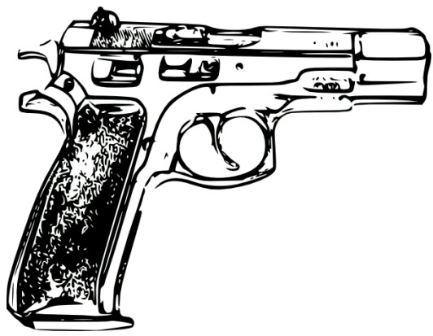

____________ ________

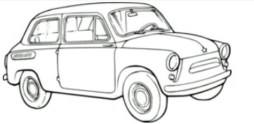

1. Matching objects to letters

**A**



**C**



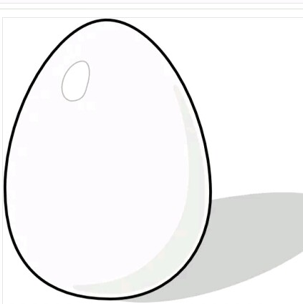 **E**

**B**



**G**

